Q1.
Answer is A.

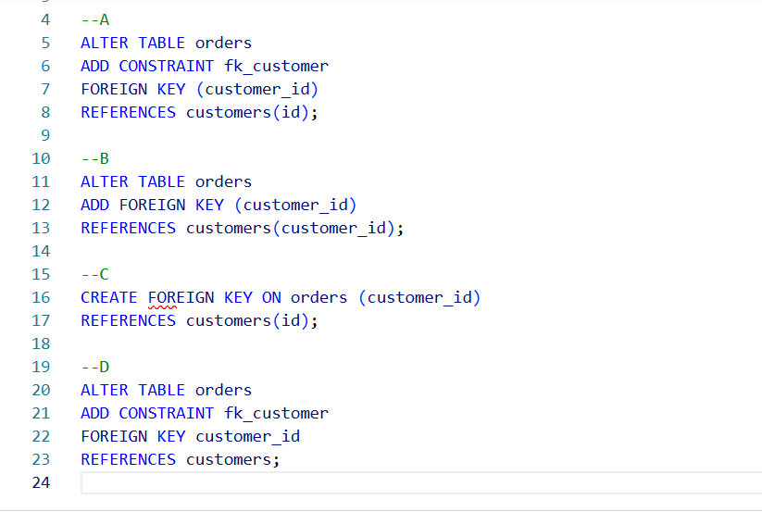

A: Correct. This is standard, valid SQL syntax.

B: Incorrect. Possible but not clearly intended.

C: Incorrect. this is invalid syntax in SQL.

D: Incorrect. This is invalid syntax in SQL.

Q2.
Answer is B.

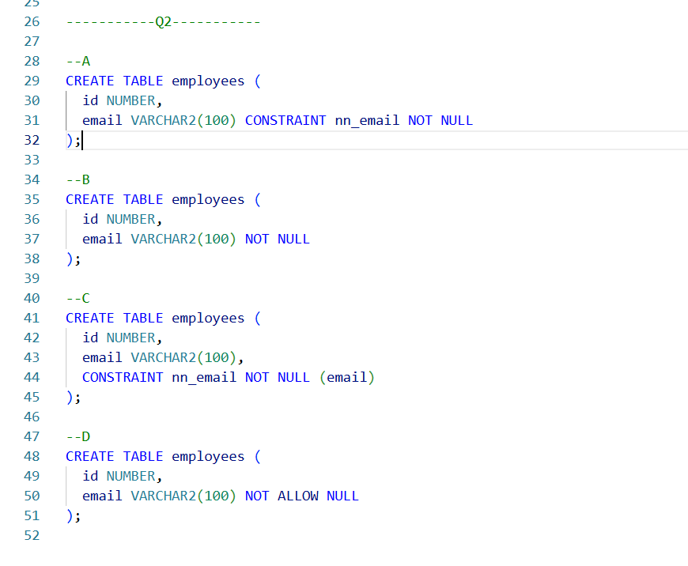

A: Correct. It adds a NOT NULL constraint to the email column and also gives the constraint a name (nn_email).

B: Correct. A simpler way to define the NOT NULL constraint.

C: Incorrect. Invalid syntax.

D: Incorrect. Invalid SQL keyword.

Q3.
Answer is A.

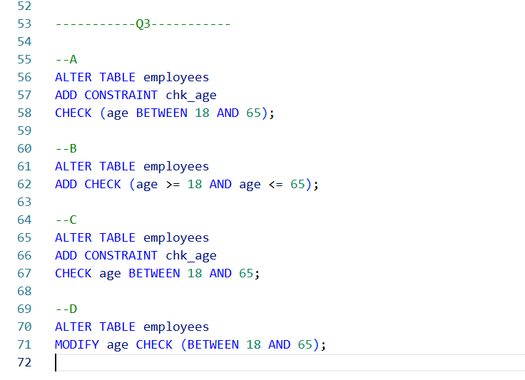

A: Correct. Valid SQL syntax.

B: Also correct. also a valid syntax.

C: Incorrect. Invalid syntax.

D: Incorrect. Invalid syntax because MODIFY is not the correct command for adding constraints.

Q4.
Answer is A.

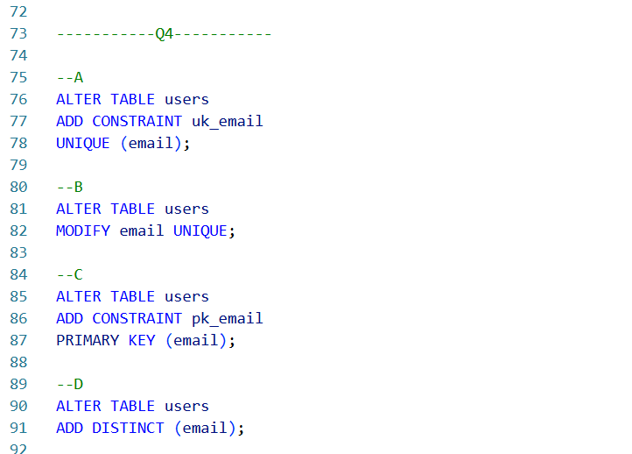

A: Correct. Used UNIQUE(email) This prevents duplicates in the email field.

B: Incorrect. Invalid syntax.

C: Incorrect. Primary key make indentification. it's not ideal for enforcing uniqueness of email addresses.

D: Incorrect. is invalid because DISTINCT is a SELECT keyword, not used for constraints.

Q5.
Answer is A.

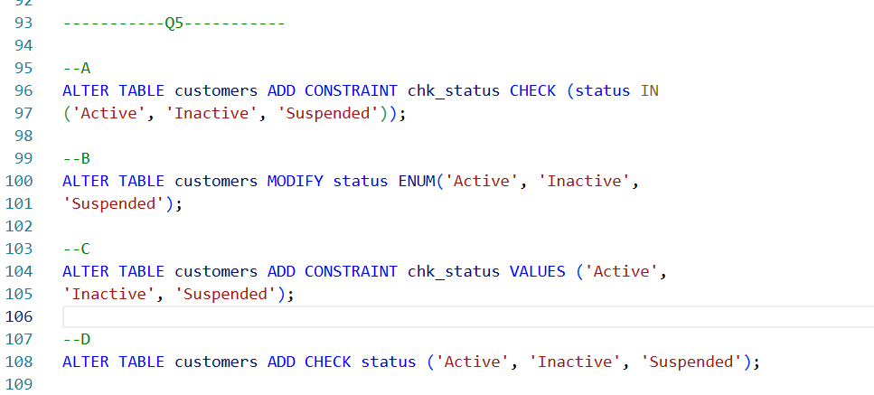

A: Correct.
It uses the CHECK constraint with the IN operator to restrict the values in the status column to 'Active', 'Inactive', or 'Suspended'. This is a valid and commonly used approach.

B: Incorrect.
This approach uses ENUM to restrict the values.
And it changes the data type.

C: Incorrect.
You cannot define a constraint with VALUES.

D: Incorrect.
Syntax error.

Q6.
Answer is B.



A: Incorrect.
Correctly enforces product_code to be unique and not null, but does not make it the primary key.

B: Correct.
Correctly defines product_code as the primary key, fulfilling all requirements (unique, not null, primary identifier).

C: Incorrect.
Correctly defines product_code as the primary key but includes a redundant uniqueness constraint.

D: Incorrect.
Ensures uniqueness and not null, but does not define product_code as the primary key, making it incomplete.
Q7.
Answer is B.



A: Incorrect. so a customer could technically have a null email, which may not be ideal.

B: Correct. This option correctly enforces that customer_id is unique and not null, that email is both unique and not null, and that name is not null.

C: Incorrect. it is also possible for a customer to have a null email.

D: Incorrect. it does not enforce the not null constraint on email.

Q8.
Answer is A.



A: Correct.
Correctly implements the many-to-many relationship with appropriate constraints, using a junction table with composite primary keys and foreign keys.

B: Incorrect.
Implements a one-to-many relationship between books and authors, not suitable for a many-to-many relationship.

C: Incorrect.
Also implements a one-to-many relationship by placing book_id in the authors table, which is not correct for many-to-many.

D: Incorrect.
Almost correct, but it misses a primary key or unique constraint in the book_authors table to ensure uniqueness of book-author pairs.

